

SINDH MADRESSAH TUL ISLAM BOARD

TRAINING REPORT

S. No | Date | School Name | Participant | Facilitator | Venue | Time

ORGANIZED BY:
SINDH MADERESSAH TUL ISLAM BOARD
Day 01
Introduction to lesson planning
Overview: Brief introduction to the importance of lesson planning
Objectives: Understand the purpose and components of a lesson plan
Components of a lesson plan: Objective, materials, activities, assessment and reflection.
Smart Objectives: Specific, Measurable, Achievable, Relevant, Time – bound Objectives.
Activity: Breakout groups to write sample objectives.
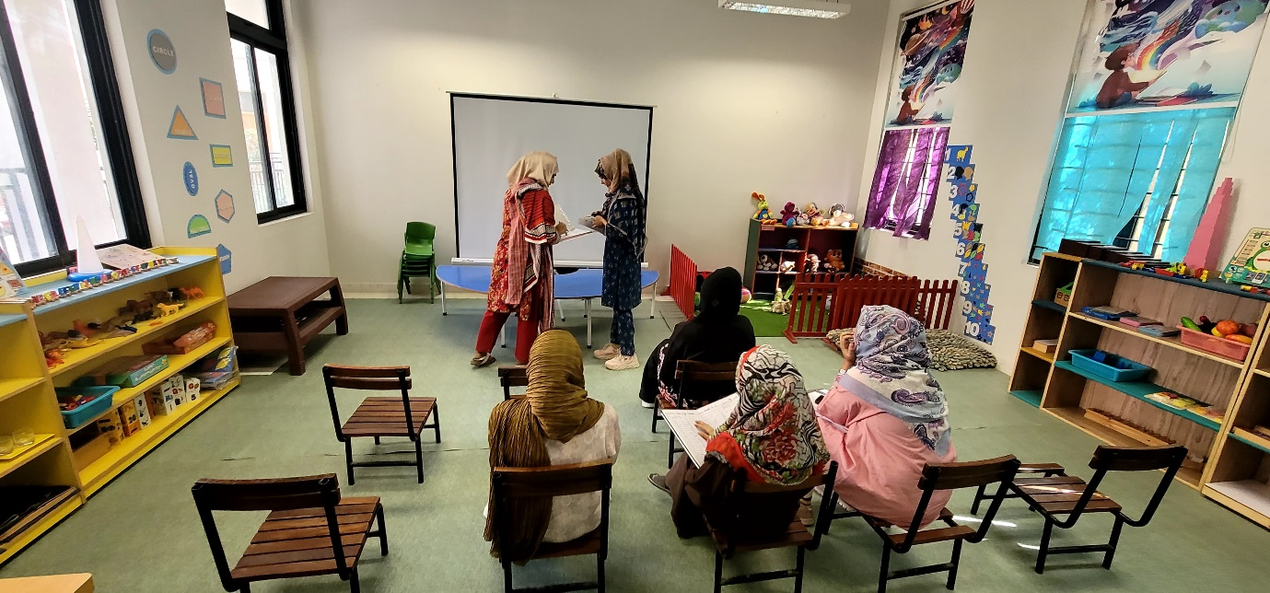

- Structuring a Lesson Plan
- Techniques for capturing student interest.
- Detailed steps for delivering content.
- Effective ways to wrap to wrap up a lesson and reinforce learning.
- Teachers create a skeleton lesson plan for a given topic.

- Interactive Teaching Methods
- Discussion on various interactive teaching methods (group work, hands-on activities, multimedia).
- How to integrate these methods into the lesson plan.
Activity: Group design an interactive activity and integrate it into their skeleton lesson plan.

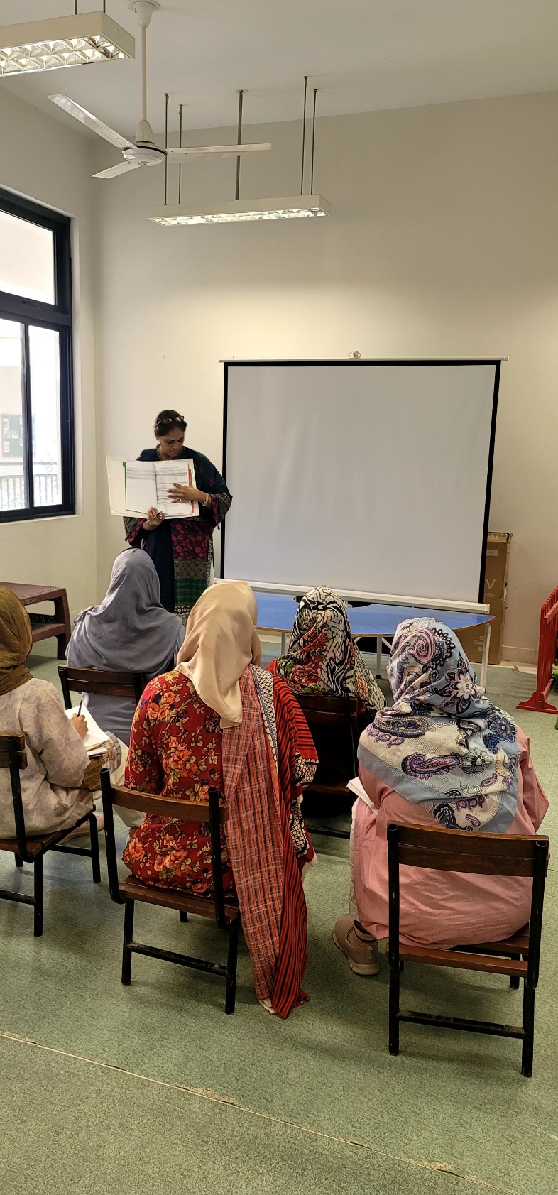

Day 02
Refining and Practicing Lesson Plans
- Review and Feedback
- Teachers present their skeleton lesson plans for peer feedback.
- Group discussion on strength and areas for improvement.
- Differentiation and inclusion
- Techniques to adopt lessons for different learning styles and abilities.
- Ensuring lesson plans are inclusive of all students.
Activity: Modify existing lesson plans to include differentiation and inclusive strategies.
- Assessment and Reflection
- Understanding different types of assessment.
- How to incorporate assessment into lesson plans.
- Techniques for self-reflection and continuous improvement.
Activity: Teachers develop assessment methods for their lesson plans.
- Final Presentation and Feedback
- Teachers present their final lesson plans
- Facilitator and peer feedback
Q&A Session: Open floor for questions and discussions on lesson planning challenges.

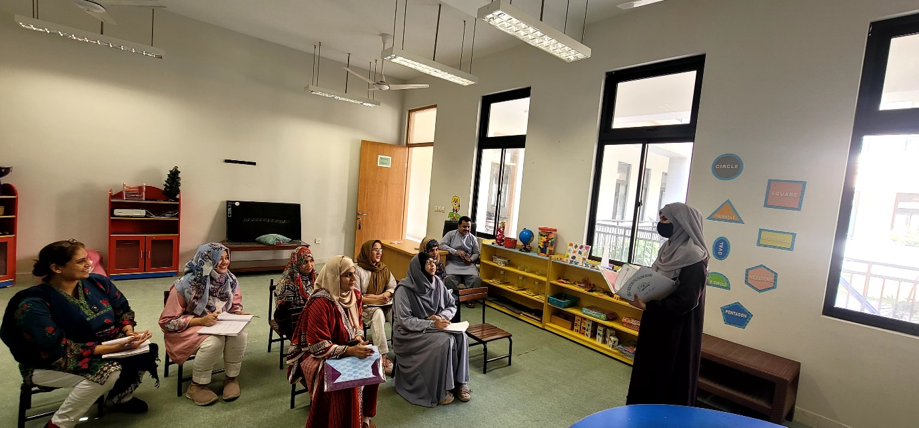

LEARNING OUTCOMES
By the end of the training, teachers were able to:
- Recognize the role of a well- structured lesson plan in effective teaching.
- Formulate clear and achievable learning objectives for their lessons.
- Develop detailed lesson plans that include engaging introductions, development activities, and conclusive elements.
- Integrate various interactive and engaging teaching strategies into their lesson plans.
- Modify lesson plans to cater to diverse learning needs and ensure inclusivity.
- Effectively incorporate formative and summative assessments into their lesson plans.
- Use self- reflection techniques to continuously improve their lesson planning and teaching methods.
Conclusion: The training was successful in equipping rural school teachers with the necessary skills and knowledge to develop effective lesson plans, ultimately enhancing the quality of education in their class rooms. the hands- on activities, group discussions, and peer feedback sessions were particularly beneficial in providing practical beneficial in providing practical experience and collaborative learning opportunities. However, During the teacher training sessions on lesson planning, I encountered several challenges. One teacher was notably inactive and appeared disengaged, even to the point of dozing off. Additionally, some teachers were unable to complete the required form due to a lack of awareness about the training. in response, I attempted to motivate the teachers and adjusted my training methodology to make the sessions more effective. And I also encountered a language barrier. To ensure effective communication, I switched to Sindhi and Urdu, as o assumed these languages would be more convenient for the participants. The adjustment helped make the training more effective.

